ELECTRIC HEATERS IKI pricelist -particulier

Name heater | 1  Fixed control | 2  Finladia control unit  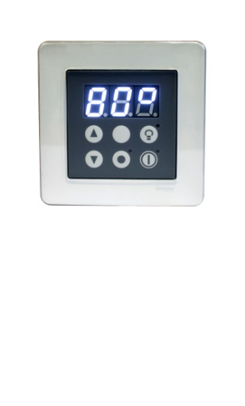 | 3  Wave  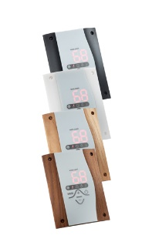  controle unit | 4  Pro-B2 control unit  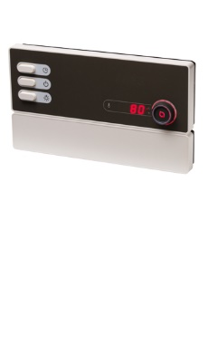 | 5  Without control | 6  Pro-b2  Control  + week  Program  Unit  = you can program the heater for a week.
Pillar-iki  4,5 kw | € 1129 | € 1239 | €1426 | €1426 | €866 | /
Pillar- iki  6 kw | €1214 | €1290 | €1502 | €1502 | €934 | /
Pillar -iki  7,5 kw | €1307 | €1426 | €1604 | €1604 | €1027 | /
Pillar - iki  9 kw | €1426 | €1570 | €1748 | €1748 | €1112 | /
Pillar - iki  10 kw | / | €1638 | / | €1884 | €1256 | €2062.50
Pillar - iki  12 kw | / | / | €2241  Included power booster | €2241  Included power booster | €1468 | €2410  Included power booster
Pillar - iki  15 kw | / | / | €2495  Included power booster | €2495  Included power booster | €1723 | €2665  Included power booster
Pillar - iki  18 kw | / | / | €3412  Included power booster | €3412  Included power booster | €2614 | €3581.50  Included power booster
Name heater | 1  Fixed control | 2  Finladia control unit | 3  Wave  controle unit | 4  Pro-B2 control unit | 5  Without control | 6  Pro-b2  Control  + week  Program  Unit  = you can program the heater for a week.
Pillar-iki  20 kw | / | / | €3904  Included power booster | €3904  Included power booster | €3123 | €4074  Included power booster
Pillar-iki  24 kw | / | / | €4243  Included power booster | €4243  Included power booster | €3482 | €4430  Included power booster
Pillar-iki  30 kw |  |  | €5101  Included power booster | €5101  Included power booster | €4294 | €5279  Included power booster

